Tex At Site Project

1. React and Electron Configuration
2. Inside the project folder >>> npm init electron-app@latest tex-project --template= webpack
3. Npm install –save-dev @babel/preset-react babel-loader @babel/core --- this is for react
   1. Babel/pre-set-react is for the jsx
   2. Babel/core it comes standard with electron; this is just to ensure that the babel/core is installed
4. Add the following in the webpack.rules.js
   1. A screen shot of a computer code

      Description automatically generated
   2. This is rule config for webpack to handle javascript
5. Npm I react react-dom
6. Create the index.jsx inside the /src
   1. A screenshot of a computer program

      Description automatically generated
7. In the renderer.js import ‘./index.jsx’ instead of ‘/index.css’
8. Create the App.jsx in the /src
9. Import the <App /> in the index.jsx. Make sure to include theextension for the App
10. Npm start. The app should be running now
11. Remove the window menu and do not open the console window automatically
    1. In main.js, comment out the window loader
       1. A screenshot of a computer program

          Description automatically generated
    2. Remove the Menu Bar
       1. A computer screen shot of a program code

          Description automatically generated
12. Incorporating tailwind in an electron-react application
    1. Npm I –save-dev tailwindcss postcss-loader autoprefixer postcss
    2. Npx tailwindcss init >>> initialize tailwind and create the tailwind.config.js
    3. Npm i @tailwindcss/forms @tailwindcss/typography @tailwindcss/aspect-ratio
    4. Setup the tailwind
       1. At webpack.renderer.config – add the tailwind plugins
          1. A screen shot of a computer program

             Description automatically generated
          2. A screen shot of a computer

             Description automatically generated
       2. In webpack.rules.js
          1. A screenshot of a computer program

             Description automatically generated
       3. A screen shot of a computer program

          Description automatically generated
    5. In the tailwind.config.js
       1. A screen shot of a computer

          Description automatically generated
       2. 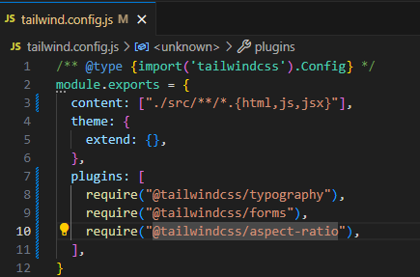
    6. In the index.css – add the directives
       1. A screenshot of a computer

          Description automatically generated
       2. A screen shot of a computer program

          Description automatically generated
       3. Import this index.jsx